EE052
PRINCIPLES OF EE1 LAB

LAB 3

Thevenin Theorem

Full name:………………………………..
Student’s ID:……………………….........
Class:……………………………………..
Date:……………………………………...
- OBJECTIVES
      - To find experimentally the values for a Thévenin's equivalent of a circuit.
      - To check the experimental values versus calculated values.
      - To find the conditions for maximum power delivered to a load.
      - To build a Thévenin equivalent of the original circuit and check to see if it really is equivalent.
- INTRODUCTION

1. Thévenin's theorem
- Given a linear circuit.
  - Rearrange it into Network A and Network B.
  - If dependent sources exist, the control variable must be in same Network.
- Define (or calc.) the open circuit voltage, Voc, across the Network A terminals with:
      - Network B disconnected.
      - IL = 0 (no current drawn from Network A by Network B).
- "Kill" Network A (make it a "dead" Network) with:
- A Short Circuit replaces all independent Voltage sources.
- An Open Circuit replaces all independent Current sources.
- If dependent sources exist they must be left in the circuit.
- Then calculate R_{th} for the "dead" Network A (looking back into the terminals). If the dead network contains dependent sources, then an external source must be connected between the two terminals to determine the impedance. Either a current source can be connected and the voltage across the source determined or a voltage source may be used and the current flowing from the source calculated. The ratio of the voltage to the current will give the Thévenin Equivalent impedance.
- Replace Network A with:
- Independent Voltage source equal to V_{oc}.
- Connected in series with R_{Th}.
- Draw Thévenin equivalent circuit.
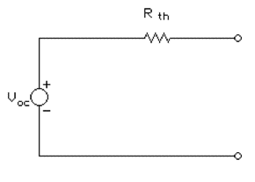
Figure 1
I_{sc} = V_{oc}/R_{Th} is the current that flows when a short circuit is placed across the terminals.
2. Norton's theorem
- Given a linear circuit.
- Rearrange it into Network A and Network B.
- If dependent sources exist, the control variable must be in same Network .
- Define (or calc.) the short circuit current, Isc, through the Network A terminals with Network B disconnected and replaced with a Short Circuit. This will give, VL = 0, since no voltage can appear across a short circuit.
- "Kill" Network A (make it a "dead" Network ) with:
- A Short Circuit replacing all independent Voltage sources.
- An Open Circuit replacing all independent Current sources.
- If dependent sources exist they must be left in the circuit. Then calculate R_{th} for the "dead" Network A (looking back into the terminals). If the dead network contains dependent sources, then an external source must be connected between the two terminals to determine the impedance. Either a current source can be connected and the voltage across the source determined or a voltage source may be used and the current flowing from the source calculated. The ratio of the voltage to the current will give the Thévenin Equivalent impedance.
- Replace Network A with:
- An Independent Current source equal to I_{sc}.
- Connected in parallel with R_{th}.
- Draw Norton equivalent circuit.
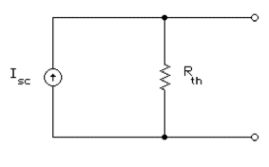
Figure 2
V_{oc} = R_{Th}I_{sc} is the voltage between the terminals with no external load connected.

Pre-Lab

Given a circuit as shown in below figure

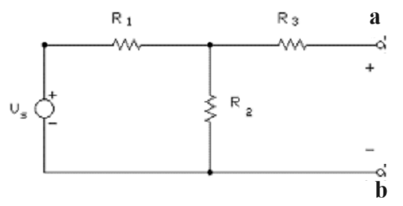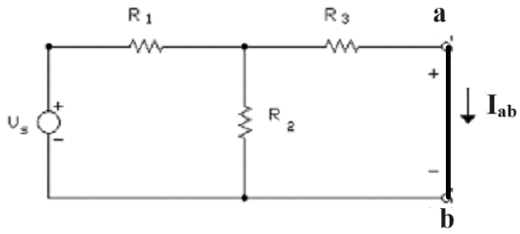
(a) (b)
Figure 3
R₁ = 1.5 kΩ, R₂ = 1.8kΩ, R₃ = 1.2 kΩ
      - Calculate V_{ab} in figure 3 (a)
      - Calculate Iab in figure 3 (b)
      - Calculate the equivalent resistance Rab
      - If a resistor R_{L} connect to two terminals a and b. What is the value of R_{L} so that the power absorbed by R_{L} is maximum

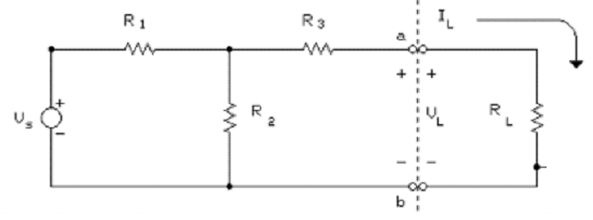

- EQUIPMENT AND PARTS LIST
      - Variable Voltage Supply
      - Breadboard
      - Digital Multimeter (DMM)
      - Fixed Resistors: 1.0 k, 1.2 k, 1.5 k, 2-1.8 k, 2.2 k, 5.6 k
      - Variable Resistance: 1 k

- PROCEDURES
      - After measuring the actual resistor values, construct the source circuit shown in Figure 1 using a variable voltage supply, breadboard, resistors, and jumper wires. Set the supply voltage as close to 15 volts as you can and record the actual value measured by the DMM.
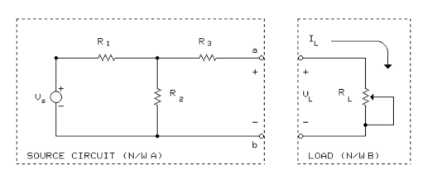
Figure 1: Original circuit and variable load.
R₁ = 1.5 kΩ, R₂ = 1.8kΩ, R₃ = 1.2 kΩ
      - Measure the open circuit voltage (V_{Th}=V_{oc}) of network A between terminals a and b.
      - Measure the short circuit current (I_{Sc}) of network A from terminal a to terminal b.
      - Calculate the Thévenin Equivalent resistance using these two measured values. Use Rth = VTh / ISc for this calculations . In the circuit shown below the portion to the left of terminals a and b is the Thévenin Equivalent of the original circuit and the portion to the right of the terminals is the load. Analyze the circuit in figure 2 to find, VL, as a function of RL. Use voltage division to find VL. Then solve for the value of RL as a function of VL. Use the values found above to calculate the values of load resistance, RL, that will give each of the following load voltages: VL = 0.7*VTh , VL = 0.5*VTh , and VL = 0.3*VTh. Note: For VL = 0.7*VTh =VL this gives VL = 0.7*VTh = VTh * RL/(RL + Rth ) or 0.7 = RL/( RL + Rth ). Solve for RL and repeat for 0.5 and 0.3.
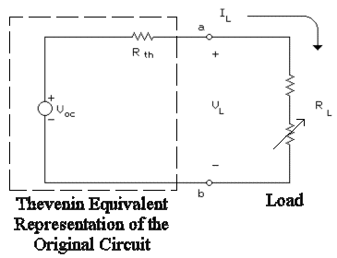
Figure 2: Thevenin equivalent with a variable load attached.
      - Then using a variable resistance (1 KOhm potentiometer) in series with a fixed resistor of appropriate value for each of these values of R_{L}. Use the closest standard resistor less than R_{L} for the fixed resistor. This should give sufficient adjustment range to get the desired output voltage when the series combination is connected across the terminals a-b of the original circuit. Adjust the resistance to obtain the corresponding value of V_{L} . Then measure the actual value of V_{L} and R_{L} (the series combination of the fixed resistor and the adjustable resistor) for each of the three specified load voltages.
V_{L}  Approximate |  | V_{L}  Measured | R_{L}  Measured | I_{L} = V_{L} /R_{L}  Calculated
Desired  value | Calculated  value | V_{L}  Measured | R_{L}  Measured | I_{L} = V_{L} /R_{L}  Calculated
0.7 *V_{Th}
0.5 *V_{Th}
0.3 *V_{Th}
Calculate I_{L} from the measured values of V_{L} and R_{L} and put it into a tabulation similar to the one shown above.
      - Disconnect V_{s} from the circuit and replace it with a jumper wire (short circuit). This is equivalent to V_{s} = 0. Then measure the Thévenin equivalent resistance (R_{Th}) looking into this source free version of the original circuit between terminals a and b. This should be very close to the value calculated by dividing the open circuit voltage by the short circuit current.
      - Construct a Thévenin equivalent circuit using the values of V_{Th} and R_{Th} obtained in steps 2 and 6, respectively. Use an appropriate fixed resistor and the potentiometer and set the series combination to the measured value of R_{th}. Use a variable voltage supply for V_{Th}, and set it to the measured value of V_{Th}.
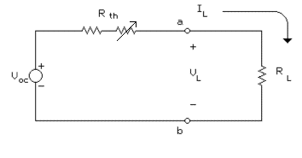
Figure 3: Thévenin equivalent with fixed load attached.
Now use the fixed resistors listed below as R_{L}. For each value of R_{L}, measure R_{L}, and V_{L}. Then calculate I_{L} using the measured value of the load resistor and voltage. Record the data in a form similar to the table below.
R_{L}( kΩ) | R_{L}( kΩ) | V_{L}(V) | I_{L}(mA)
Nominal | Measured | Measured | measured | Calculated
0
1.0
1.8
2.2
5.6
open
CALCULATIONS, COMPARISONS & GRAPHS:
- From the data in step 5 under procedure use a spreadsheet to plot a graph of VL (y axis) versus IL (x axis) using an open circle as the symbol with no line connecting the points. Also plot on the same graph the points for (VTh = VOC, IL = 0) and (VL = 0, IL = ISC ) connected with a line. Do the original data points lie on this line?
- Now on the same graph plot the data from step 7 under the PROCEDURE. Use an open square box symbol to identify these points, but do not connect the points with a line. Identify each set of data with a legend at the bottom of the graph.. Is the Thévenin circuit in Figure 3 equivalent to the original circuit in Figure 1? If so, why can you make that statement?
- Next, using the data from step 5 under the PROCEDURE, calculate the power (P) delivered to R_{L}. On a separate graph plot P (on the y axis) versus R_{L} (on the x axis) using an open circle for each point with no connecting lines. Add the points from step 7 using an open square box for each point. Do not connect either set of points with a line. Plot the theoretical power curve from R = 0 to R = 5 kΩ on the same graph using a step size of 0.1 kΩ so that the line connecting these points with no symbols will form a smooth curve. At what value of resistance does the power reach a maximum? Does this make sense? How close are the two sets of experimental points to the theoretical curve?
- Calculate V_{Th}, I_{sc} and R_{th} of circuit in Figure 1 using the measured source and resistor values and compare them to measured values in steps 2, 3, and 6 of the PROCEDURE.

